**Charter: PetHome**

**Project Name:** PetHome

**Sponsor:** JD

**Product Owner:** Thiago Cavalcante

**Software Engineer:** Edgar Martinez

**Project Definition**

This is a Full Stack RESTful Application whose purpose is to encourage people out there to adopt a pet instead of purchasing it.

There are hundreds of pets outside on the streets that would love to have a home. So, through this application, someone can take them out of the streets and broadcast an adoption. So that, those who would be interested in any pet, can apply to adopt it after verifying some security data.

**User Stories**

* As a member I want to be able to have a username for this app
* As a member I the pet adoption status
* As a member I want to be able to post a pet in adoption
* As a member I want to see different pets to adopt a pet
* As a member I want to be able tag and apply for multiple adoptions
* As a member I want to be able to see a gallery of pets in adoption in a region
* As a member I want to see more details of a pet in adoption
* As a member who publishes an adoption, I want to have options to either approve or reject the adoption request
* As a member I want a direct link to a region selection to get the adoption gallery
* As a member I want to be able to remove my user from the application

**Project Plan**

Technology Stack to develop this application:

* HTML 5
* CSS
* Javascript
  + Node.js
  + Json
  + Sequelize
  + EJS
* Postgres Database

All documentation will be stored into the PetHome Project repository setup on GitHub under “emdlr” user account. This full stack application will be rendered on the browser.

**Project Start Date:** Friday July 31st, 2020

**Deployment Day:** Friday August 7th, 2020

**Rollout**: Friday August 7th, 2020

Often commits on GitHub will be required.

**Project Design**

**Technologies**

* Visual Studio Code – Main Development Tool
* Web Browser – Google Chrome
* Programing language – Javascript
* Styles Formats – Cascading Style Sheets
* Web Design Platform – HTML 5
* PG Admin – As Database Manager
* Git/GitHub Repository
* Heroku for site deployment.

**Database E-R Diagram**

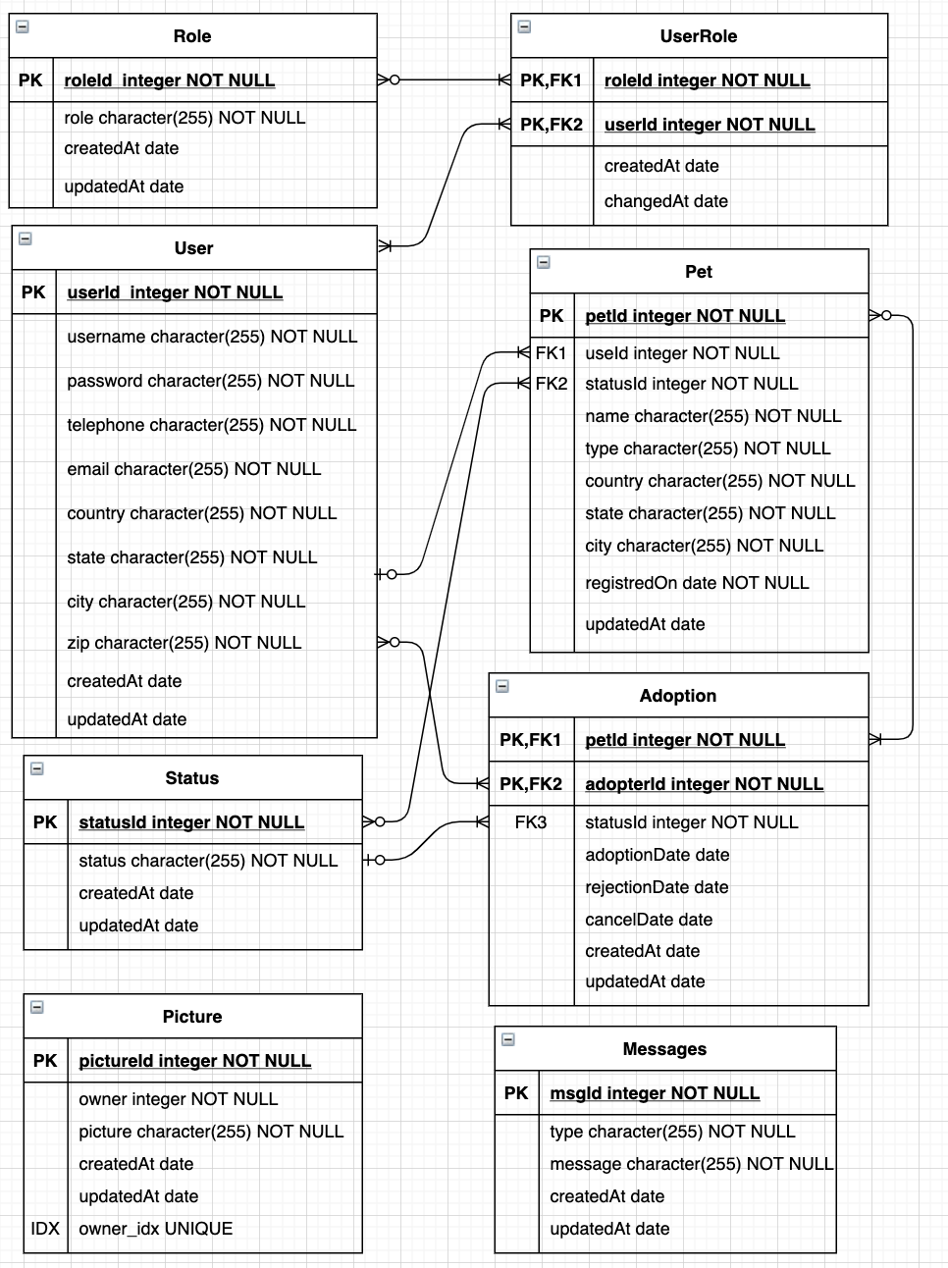

**Flow Diagram**

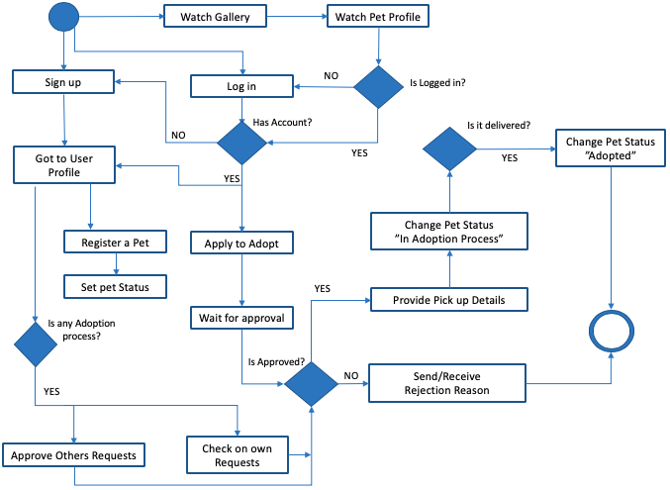

**Wireframes**

|  |
| --- |
| **Home Window** |
| BIENVENIDO  A  PETHome  Creado por Edgar  Se parte de esta gran labor  Quiero: |
| **Sign Up Window** |
| Registro  Creado por Edgar  Apellido:  Nombre:  Correo:  Teléfono:  Estado:  Dirección  Ciudad:  CP:  Contraseña:  Grabar |
| **Login Window** |
| BIENVENIDO  A  PETHome  Creado por Edgar  Se parte de esta gran labor  Quiero:  INGRESAR  Usuario:  Contraseña:  Ingresar |
| **Pet Gallery Window** |
| Galeria  Creado por Edgar  Ver todos:  Estado:  Ciudad:  X  Tipo: |
| **Pet Profile Window** |
| Perfil Mascota  Creado por Edgar  Nombre:  Raza:  Estado:  Ciudad:  Color:  Contactar  Comentarios:  Estatus: |
| **User Profile Window** |
| Hola! Usuario  Creado por Edgar  Apellido:  Nombre:  Correo:  Teléfono:  Estado:  **Dirección**  Ciudad:  CP:  Contraseña:  Editar  Borrar Perfil  **Tus Mascotas en Adopción**  **Tus Mascotas Adoptadas** |

**Roadblocks**

Understand how to handle Models relationships according to sequelize logic

**What are the next steps?**

This application will have an S.O.S functionality in which those who sign up, will have the option to volunteer as a rescuer in their city, these will receive an email with the report of whoever is signed up to this app.

**Installation**

* Internet Connectivity
* No high Internet speed required
* Click on the LINK and pet your family member !

**More Data** You can also take a look to the project document for more info.

https://pethomeapp.herokuapp.com/ | <https://git.heroku.com/pethomeapp.git>

Pic Rep:

<https://www.pexels.com/search/pet/>